**The Twelve Houses**

[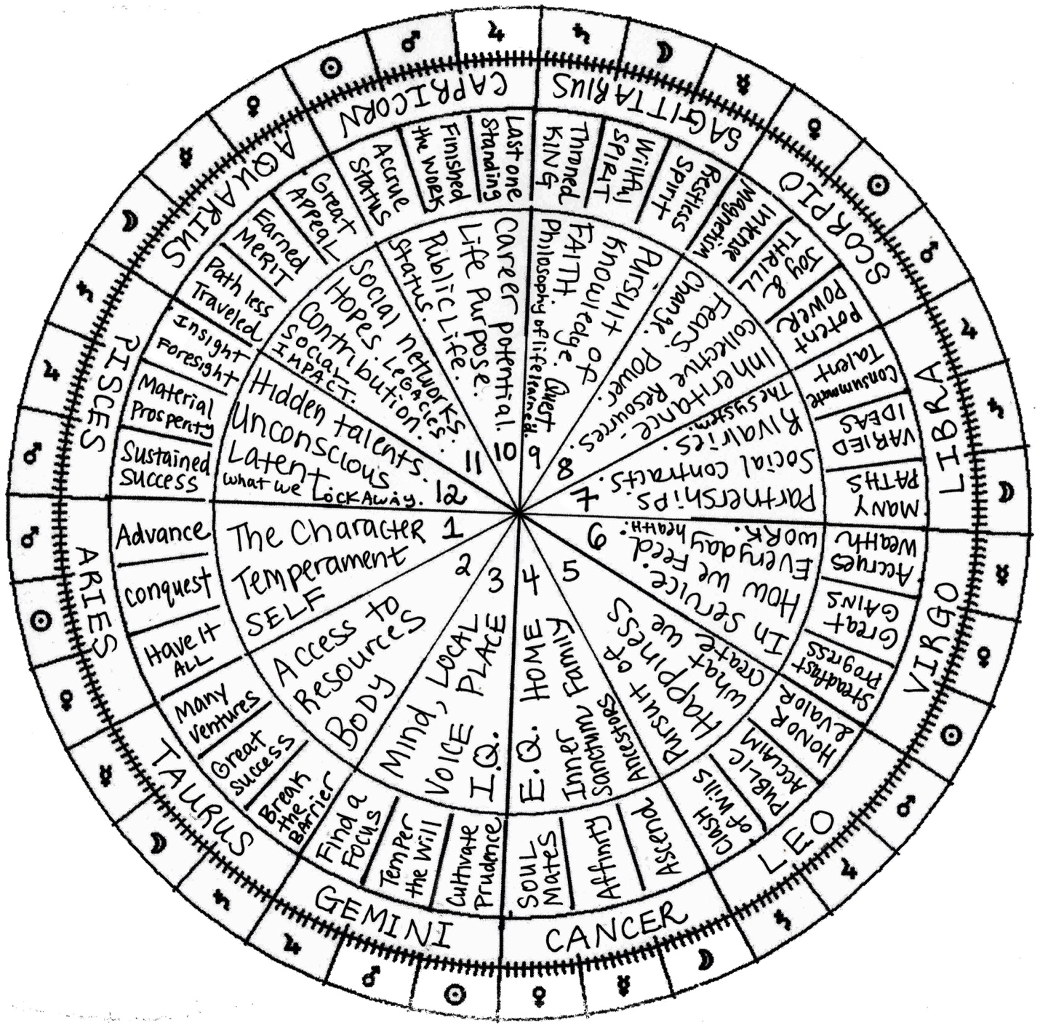](https://benebellwen.com/wp-content/uploads/2024/12/twelve-astrological-houses-signs-36-decans.jpg)*The 12 Astrological Houses, Signs, and 36 Decans*

THE TWELVE HOUSES

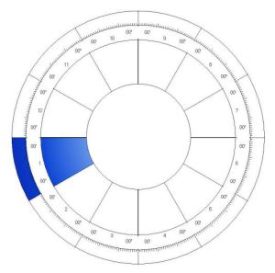

**The First House: Life, Body, Spirit, Beginnings**

The first house is also your ascendant or rising sign, which we covered in “The Self” section. This house is an angular or cardinal house, which means what goes on in this house is quite forceful and prevalent in your life, and will often reveal information about yourself you’ve already come to know. It’s also one of the houses in your natal chart that’s going to have the most impact on you.

This is the Helm, destiny in the making, awareness of the self, and angle of fulfillment. Here we see the influences at play *before*birth. House 1 in a horary chart reading indicates the present status of the matter. In natal astrology, it can reveal aspects of identity and the native’s external character, physical appearance, highest potential, characterization of free will, and core persona or complexion.

*In Mundane Astrology*: The kingdom and its people; the masses; in a political campaign, signifies the Majority; an organization’s personnel.

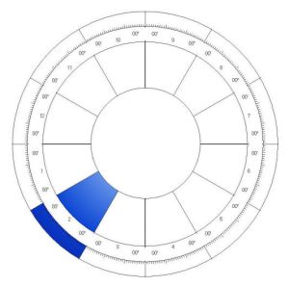

**The Second House: Livelihood, Possessions, Money Matters**

This house is a succeedent house, which simply means “following” or “subsequent to” the leading angular house. As a succeedent house, this is a house that provides support. This house will speak to your belongings, to what is yours, and what is supportive of the preceding angular house before it. In this case, the second house supports the angular first house.

In Hellenistic astrology, the second house is the Gate of Hades. Here we also see the influence of Persephone. In general chart interpretation, House 2 denotes money matters, access to resources, and your keys to wealth. It also relates to the physical body. Read House 2 and House 6 together for health considerations.

Can also reveal the native’s strongest desires and wishes out of life; financial standing; earning and spending capacities.

*In Mundane Astrology*: Kingdom’s wealth; economy; the stock exchange; national exports; the Treasury; an organization’s assets and liabilities.

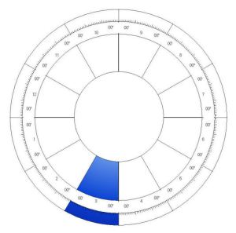

**The Third House: Siblings, Travel, Thoughts, Mental State**

This house is a cadent house, the last house in each quadrant of your natal chart. Planets in this house are often going to have less of an impact at birth and will have greater impact as you grow. Cadent houses indicate areas of learning for us, areas where we must transform ourselves, grow, improve, and further develop from weakness to strength. In other words, cadent houses show areas of nurture, whereas the other houses, the angular and succeedent, can be thought of as more indicative of your nature or what you are born with.

The third house is ruled by Mercury and the element Air. This is the house of communications and will note how you think and then how you communicate what you think to others. This is the synthesizing powers of the mind; character and strength of one’s willpower to change fate. To know more about someone’s mental state and thought process, look to their House 3.

Traditionally it is also the house of siblings and early childhood, short journeys, neighbors, siblings, writings and communications; can also be the house of early childhood accidents. Childhood memory.

*In Mundane Astrology*: Transportation and telecommunications. Transit. Climate. Relations with neighboring kingdoms. Spokesperson, brand reputation, and corporate messaging of an organization.

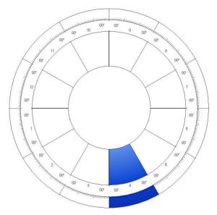

**The Fourth House: Parents, Emotions, Inner Sanctum, Mystical Matters**

This house is an angular or cardinal house, which means what goes on in this house is quite forceful and prevalent in your life, and will often reveal information about yourself you’ve already come to know. It’s also one of the houses in your natal chart that’s going to have the most impact on you.

The fourth house is ruled by the moon and the element water. It is the house of our home and hearth. What goes on here can indicate our relationship with our parents in our youth and then our relationship with our family in our adulthood. Hereditary matters are often denoted in this house. Aspects of your past life and soul purpose can be found here, as with matters relating to your roots and heritage. The fourth house can also manifest an innate artistic talent.

House 4 is the Seat of the Soul, and the house of the subterranean angle. What aspects of childhood will most influence this native? What aspects of heritage, domestic matters, and ancestry are of most impact? House 4 also reveals hereditary tendencies and what one’s roots are. This is where much is buried.

*In Mundane Astrology*: In politics, the opposition. The challenger to the incumbent. In litigation or trial, this is the jury or judge. Principal place of business for an organization; base operations.

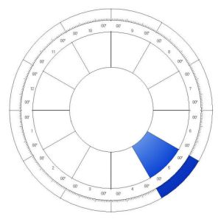

**The Fifth House: Children, Pursuit of Happiness, Leisure**

This house is a succeedent house, which simply means “following” or “subsequent to” the leading angular house. As a succeedent house, this is a house that provides support. This house will speak to your belongings, to what is yours, and what is supportive of the preceding angular house before it. In this case, the fifth house supports the angular fourth house.

The fifth house is ruled by the sun and the element fire. It is the house of creativity and fertility. It can show our creations, our children or progeny, and our personal pursuits. The fifth house can reveal what our hobbies are, or areas that are going to be of general interest to us. This house can also indicate our love affairs and secondary relationships.

House 5 is called the House of Good Fortune. What is the nature of blessings you are most likely to be innately endowed with in this lifetime? Also, what makes you happy? What brings you joy? House 5 can tell us a lot about how we can successfully navigate society, given our particular personality disposition.

Reveals the exteriorization of the self through self-expression; how does this native want to be perceived by others. How strong are the native’s impulses. Planets occupying the fifth house indicate one’s emotional desires.

*In Mundane Astrology*: Education, schools; entertainment industry. The legislature. In an organization, corresponds with the board of directors or the governing body of the organization, but not the president or chairman.

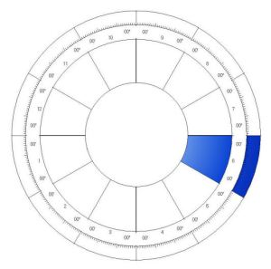

**The Sixth House: Occupation, Productivity, Service, Health**

This house is a cadent house, the last house in each quadrant of your natal chart. Planets in this house are often going to have less of an impact on your manifested life path. Yet these houses indicate areas of learning for us, areas where we must transform ourselves, grow, improve, and further develop from weakness to strength. In other words, cadent houses show areas of nurture, whereas the other houses, the angular and succeedent, can be thought of as more indicative of your nature or what you are born with.

The sixth house is ruled by Mercury and the element earth. It is the house that best denotes our everyday life, the mundane, our daily work, our labors, and our job. This is also the house that offers insights into our physical health, body, and wellness. Can correspond with our chattel.

If House 5 is the House of Good Fortune, then House 6 is its counterpart, known as the House of Bad Fortune. This is the fate of your everyday toil and how your labors are most likely to be utilized. If House 5 reveals what you’re passionate about, then House 6 reveals what you’re good in terms of core competencies that you can capitalize on for work and employment.

*In Mundane Astrology*: Public health; armed forces; civil servants, such as the police. The laboring class. In an organization, the sixth house corresponds with the laborers and workforce.

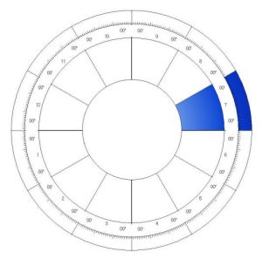

**The Seventh House: Spouse, Marriage, Institutions, Alliances, Partnerships**

This house is an angular or cardinal house, which means what goes on in this house is quite forceful and prevalent in your life, and will often reveal information about yourself you’ve already come to know. It’s also one of the houses in your natal chart that’s going to have the most impact on you.

The seventh house is ruled by Venus and the element air. It is the house of union, partnerships, and relationships. It can often indicate who our life partners will be. It is the house of marriage. This house reveals what kind of spouse you are most compatible with and can offer insights into your conjugal life. Give and take of human relations.

This is the House of the Setting Angle and indicates the influence of societal institutions in the native’s life path. Thus, House 7 can reveal matters pertaining to institutions such as marriage, religious orders, legal matters, social associations, and how the people we let into our inner circle will most influence our life path.

*In Mundane Astrology*: Social consciousness of the people or culture. Status of the kingdom among the kingdoms of the world. Organized crime. Contracts. Trade agreements. Lawsuits and legal affairs. Jurisprudence. Legal system. For an organization, its direct competitors, but also, its alliances.

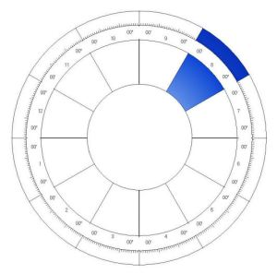

**The Eighth House: Sex, Death, Transformation, Unseen Influences, and Inheritances**

This house is a succeedent house, which simply means “following” or “subsequent to” the leading angular house. As a succeedent house, this is a house that provides support. This house will speak to your belongings, to what is yours, and what is supportive of the preceding angular house before it. In this case, the eighth house supports the angular seventh house.

The eighth house is ruled by Mars under a traditional rulership and Pluto under a modern. It is also governed by the element water. This is the house of inheritances, also oft called the occult house, the house of sexuality, power, risk, losses, desires, temptations, and how we learn to deal with our the shadow or darker side of our selves. The eighth house at the hour of birth denotes potential phases of transformations, crisis, and areas of waste in our lives that we would do well to pay attention to and thus prepare for. Represents non-material riches. What you receive that is not the result of your own labor or merit.

Traditionally matters pertaining to inheritance and estates are interpreted from House 8. This is also the House of Inactive Power, and therefore reveals otherwise unseen influences in our life. Power plays, sex, sexuality, and sex drive are expressed in a native’s House 8.

*In Mundane Astrology*: National debt; taxation; loans, lines of credit, revenue from investments.

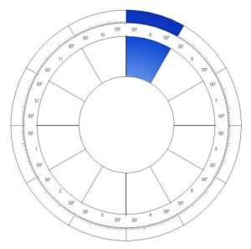

**The Ninth House: Spirituality, Long Journeys, Expansion, Great Work**

This house is a cadent house, the last house in each quadrant of your natal chart. This is going to be an area of learning for us, and what goes on in this house will denote areas where we must transform ourselves, grow, improve, and further develop from weakness to strength. In other words, the cadent ninth house show areas of higher learning, growth, and spiritual development that will further enhance and support both the preceding angular, the seventh house of our unions and relationships, and the following angular, the tenth house of our social status and career goals. Revealed here are the ongoings of the abstract mind, one’s philosophy of life.

The ninth house is ruled by Jupiter and the element fire. This house relates to how we view spirituality and religion, or mystical matters. It shows our relationship to Spirit, God, the Divine, or how well (or not well) connected we are to that collective unconscious. It is the house of divination, the house of journeys, higher education, and self-actualization. This house will offer a sense of your life philosophies.

In Hellenistic astrology, this is the House of God, of spiritual exploration, higher learning, and our connection to the greater collective or greater good. Those with a decorated House 9 tend to be more cosmopolitan, mystical-minded, and interested in diversity of thought. They also are more likely to be multicultural, bilingual, or immigrate far from their native homelands.

*In Mundane Astrology*: Foreign affairs; a nation’s secretary of state; officials and aristocracy; long-distance communications, media relations, public relations, publicity.

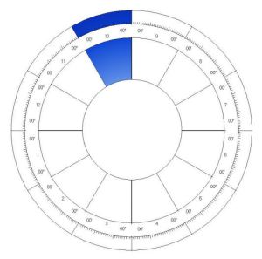

**The Tenth House: Career, Glory, Reputation, Advancement**

This house is an angular or cardinal house, which means what goes on in this house is quite forceful and prevalent in your life, and will often reveal information about yourself you’ve already come to know. It’s also one of the houses in your natal chart that’s going to have the most impact on you.

The tenth house is ruled by Saturn and the element earth. It is the house that denotes the social status we achieve in life, how we advance through life, our reputation, our professional destiny, and our aims in life. This house is the house of glory.

This is the House of the Culminating Angle, and will reveal your optimal career path, keys to social success, and potential for high achievement. House 10 is expressive of your Great Work as assigned to you by the Divine at the moment of your birth. Especially auspicious when the sun or Jupiter appears in the tenth house.

*In Mundane Astrology*: The chief executive officer; the control tower. Eminent and famous persons. The President or the Chairman of the Board.

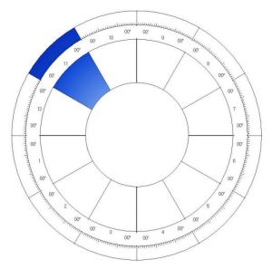

**The Eleventh House: Hopes, Gifts, Community, Networks**

This house is a succeedent house, which simply means “following” or “subsequent to” the leading angular house. As a succeedent house, this is a house that provides support. This house will speak to your belongings, to what is yours, and what is supportive of the preceding angular house before it. In this case, the eleventh house supports the angular tenth house.

The eleventh house is ruled by Saturn under a traditional rulership and Uranus under a modern. It is also governed by the element air. This is the house of community and of one’s social position in adulthood (as opposed to the status that one was born into). This house denotes who our friends are, what our relationship to our community is, and how our external selves manifest in society. This is a social house, about our group involvements, humanitarianism, and how we might contribute to our community. This is also the house that denotes our social or supportive network.

In the 21st century, House 11 is connected to social networks, social media, and our online personalities. Those with a decorated House 11 tend to be interested in politics, public interest, or social justice. This is the house of civic engagement.

*In Mundane Astrology*: Ceremonies and celebration. Social activities. Fraternal groups and organizations. A kingdom’s culture and heritage; alliances, sense of greater spiritual purpose of an entity.

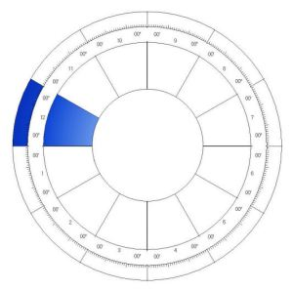

**The Twelfth House: Epiphanies, Suffering, Catharsis, Weaknesses, Hidden Dangers, Hidden Talents**

This house is a cadent house, the last house in each quadrant of your natal chart. Planets in this house are often going to have less of an impact on your manifested life path. Yet these houses indicate areas of learning for us, areas where we must transform ourselves, grow, improve, and further develop from weakness to strength. In other words, cadent houses show areas of nurture, whereas the other houses, the angular and succeedent, can be thought of as more indicative of your nature or what you are born with.

The twelfth house is ruled by Jupiter under a traditional rulership and Neptune under a modern. It is also governed by the element water. This is the house of self-awareness, but also the house of self-sacrifice. It can denote the nature of personal trials we suffer in our lives, the losses or obstacles we experience as we try to achieve our goals and self-actualization. The twelfth house will tell the story of the hero’s journey, your journey, what you must go through and endure to achieve success.

The house can also show what we perceive to be our limitations, revealing defects in character and one’s personal weaknesses. Since we perceive these attributes to be our limitations, they actually become our limitations as a form of self-fulfilling prophecy. Being conscious of the influences in the twelfth house can help us transform weaknesses into strengths.

The twelfth house is a difficult house. It is the house of suffering, but through suffering, epiphanies and awakenings. It is the house of karmic difficulties, enemies, personal inner crises, and what pains us to bring us toward self-actualization. The twelfth house tells the story of the demons we face to achieve transcendence. And so just as it is the house of hidden challenges, it is also the house of hidden talents and secret gifts for us to discover about ourselves. In past life astrology, what the twelfth house tells us is the result of karmic accounting from our past incarnation.

*In Mundane Astrology*: Plagues, epidemics; public welfare; correctional facilities and the prison system; incarceration; hospitals and charitable organizations; a nation’s enemies; crimes and criminals; secret societies.

line

In addition to what you’ve read here, be sure to download the below free resource.

[**Learning the Twelve Astrological Houses (PDF)**](https://benebellwen.com/wp-content/uploads/2016/09/learning-the-twelve-astrological-houses-2016-09-16.pdf)

This document is intended for astrology beginners. It was one of the supplements from my “Learning the Opening of the Key” tarot course provided through the Tarot Readers Academy.

[**Houses and Signs Quick Reference Sheet (PDF)**](https://benebellwen.com/wp-content/uploads/2015/10/benebell-wen-astrology-quick-reference-sheets.pdf)

These are quick reference sheets that provide a snapshot of the house, sign, and planetary correspondences. In one glance, you can absorb all the concise information you might need. For a while, these were permanent fixtures on my study desk.

[**Learning the Thirty-Six Decans (PDF)**](https://benebellwen.com/wp-content/uploads/2016/09/learning-the-thirty-six-decans-2016-09-16.pdf)

This document is intended for astrology beginners. It was one of the supplements from my “Learning the Opening of the Key” tarot course provided through the Tarot Readers Academy.

**NEXT:**[**The Twelve Signs**](https://wp.me/P32or0-1p2)